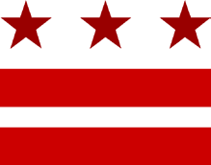
Advisory Neighborhood Commission 2A
“Serving the Foggy Bottom and West End communities of Washington, D.C.”

Bylaws Special Committee Meeting Monday, June 3rd, 2024; 7:00 p.m.
Please note that the Special Committee meeting will take place virtually.
Join online via Zoom – https://bit.ly/ANC2AJuneBylaws2024
Join via Phone – (301) 715-8592 or (646) 558-8656 with Meeting ID 860 996 8410 #.

7:00 pm I. Call to Order (10 minutes)
- Roll call
- Adoption of the agenda

7:10 pm II. Review of Bylaws Edits (70 minutes)
- Review of Bylaws edits and revisions beginning with Article I. Section 1.

8:20 pm IV. Discussion of Next Meeting Time (10 minutes)
- Discussion and selection of next meeting time

8:30 pm V. Adjournment

c/o West End Library • 2301 L Street NW • Washington, DC 20037 • www.anc2a.org

